Board of Directors Annual Meeting 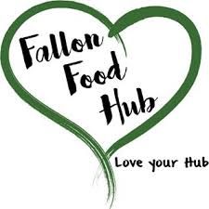
Fallon Food Hub
May 23, 2018
5:30pm
40 E. Center Street #5

Agenda Item

Public Comment

Roll Call/Welcome Guests

Approve Agenda

Approve Minutes
March 28, 2018

Finance/Treasurer Report

Approve appointment of Interim Executive Director to Executive Director

Executive Director Report
- Farm Share
- Farmer’s Market
- Events
- Other

Board Director Updates

Next Meeting: June 27, 2018

Non-agenda Items/Comments/Questions

Adjourn

