Board of Directors 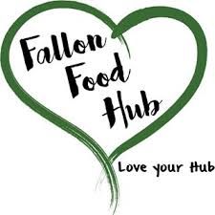
Fallon Food Hub
July 25, 2018
5:30pm
40 E. Center Street #5

Agenda Item

Public Comment

Roll Call/Welcome Guests

Approve Agenda

Approve Minutes
June 27, 2018

Finance/Treasurer Report

Executive Director Report
- Farm Share
- Farmer’s Market
- Events
- Other

Board Director Updates
- Fundraising Ideas

Next Meeting: August 29, 2018

Non-agenda Items/Comments/Questions

Adjourn

