Board of Directors Meeting 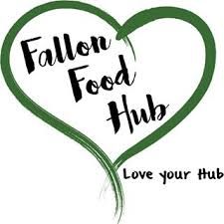
Fallon Food Hub
January 10, 2018
5:30pm
40 E. Center Street #5

Agenda Item

Public Comment

Roll Call/Welcome Guests

Approve Agenda

Approve Minutes
December 6, 2017

Finance/Treasurer Report

Interim Executive Director Report

Strategic Plan Update

Annual Meeting Update

Board Director Updates

Non-agenda Items/Comments/Questions

Adjourn

Next Meeting-Tuesday, January 30, 2018, Strategic Planning Meeting

