Board of Directors Meeting 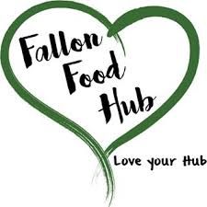
Fallon Food Hub
December 6, 2017
12:00pm
40 E. Center Street #5

Agenda Item

Public Comment

Call to Order/Welcome Guests

Roll Call

Approve Agenda

Approve Minutes
November 15, 2017

Finance/Treasurer Report
Check Signers

Interim Executive Director Report

Strategic Plan Update

Annual Meeting Update

Board Director Updates

Adjourn

Next Meeting-Wednesday, January 10, 2018-5:30pm

